**Lab Class -01**

# **Html :**

<!DOCTYPE html>

<html lang="en">

<head>

<meta charset="UTF-8" />

<meta name="viewport" content="width=device-width, initial-scale=1.0"/>

<title>Internet and Web Technology Lab</title>

<style>

body {

background-color: #f9f9f9;

font-family: Arial, Helvetica, sans-serif;

text-align: justify;

margin: 0;

padding: 20px;

}

h1, h2, h3, h4, h5, h6 {

color: #2c3e50;

}

p {

margin: 15px 0;

color: #333;

padding: 10px;

border: 2px solid powderblue;

border-radius: 8px;

background-color: #fff;

}

a {

color: #0077cc;

text-decoration: none;

}

a:hover {

text-decoration: underline;

}

img {

margin: 10px;

border-radius: 10px;

}

button {

margin-top: 15px;

padding: 10px 15px;

background-color: #28a745;

color: white;

border: none;

border-radius: 5px;

cursor: pointer;

}

button:hover {

background-color: #218838;

}

blockquote {

font-style: italic;

background-color: #f0f0f0;

padding: 15px;

border-left: 5px solid #0077cc;

margin: 20px 0;

}

mark {

background-color: yellow;

padding: 2px 4px;

}

</style>

</head>

<body>

<h1 style="font-style: italic">This is a heading</h1>

<p title="hello world">This is another paragraph with a <b>title attribute</b>.</p>

<hr />

<h6>This is a heading h6</h6>

<p>

My self <b>Ahad Ahmed.</b> <br/>

Here is my <b>Facebook link:</b>

<a href="https://www.facebook.com/" target="_blank">Facebook</a>

</p>

<a href="#del">Click to see deleted text</a>

<h3>Images:</h3>

<img src="/Project/image/480707829_938222585097553_7811148792263183938_n.jpg"

alt="My scenery" height="200" width="200"/>

<img src="/images/WhatsApp Image 2025-01-27 at 12.25.07_d3bbdbc3.jpg" alt="Girl" height="200"/>

<p style="background-color: antiquewhite">

This paragraph contains a lot of lines in the source code,

but the browser ignores them.

</p>

<strong>I am a very strong man</strong><br>

<em>This text is emphasized</em><br>

<mark>This text is highlighted</mark><br>

<small>This is small text</small><br>

<del id="del">This text is deleted</del><br>

<ins>This text is inserted</ins><br>

<blockquote cite="https://www.youtube.com/watch?v=an-FtZOWarA">

"Lorem ipsum dolor sit amet consectetur adipisicing elit.

Commodi maxime dolor non qui laborum voluptatum nam modi quae nemo architecto."

</blockquote>

<p>The <abbr title="World Health Organization">WHO</abbr> was founded in 1948.</p>

<address>Savar, Dhaka, Bangladesh</address>

<bdo dir="rtl">This text will be written from right to left</bdo>

<h3>Useful Links:</h3>

<a href="https://www.w3schools.com/html/tryit.asp?filename=tryhtml_css_fonts" target="_blank">W3Schools Practice</a><br>

<a href="mailto:mda3898145@gmail.com">Send me an email</a><br>

<a href="mailto:mda3898145@gmail.com">

<img src="/Project/image/480707829_938222585097553_7811148792263183938_n.jpg" alt="My Gmail" height="30" width="30">

</a><br>

<button onclick="window.location.href='https://www.w3schools.com/html/tryit.asp?filename=tryhtml_css_fonts'">

Visit W3Schools

</button>

</body>

</html>

# **Output:**

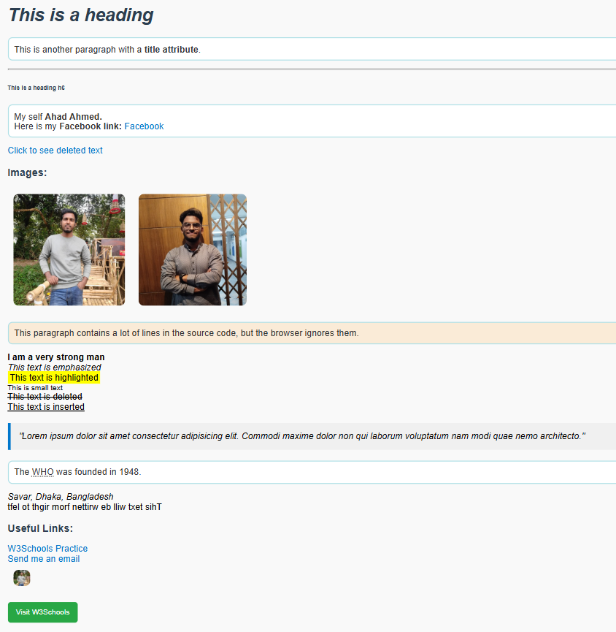

**Lab Class-02**

# **Html:**

<!DOCTYPE html>

<html lang="en">

<head>

<meta charset="UTF-8" />

<meta name="viewport" content="width=device-width, initial-scale=1.0"/>

<title>IWT Project Group</title>

<link rel="stylesheet" href="/Lab Class-2/CSS/style.css">

</head>

<body>

<!-- Header -->

<header>

<h1>IWT PROJECT GROUP</h1>

<p>Welcome to our Semantic HTML + CSS Project</p>

</header>

<!-- Navigation -->

<nav>

<a href="https://www.youtube.com/">Home</a>

<a href="about.html">About</a>

<a href="contact.html">Contact</a>

</nav>

<!-- Main Section -->

<section>

<h2>Welcome to our website!</h2>

<p>This is a sample layout for our project.</p>

<article>

<h3>Article Title</h3>

<p>This is an article section where we can add more content.</p>

</article>

<article>

<h3>Another Blog Post</h3>

<p>This is another article using the &lt;article&gt; tag.</p>

</article>

</section>

<!-- Aside -->

<aside>

<h2>Related Links</h2>

<ul>

<li><a href="https://www.example.com">Example Link 1</a></li>

<li><a href="https://www.example.com">Example Link 2</a></li>

</ul>

</aside>

<!-- FAQ Section -->

<section>

<h2>FAQ</h2>

<details>

<summary>What is semantic HTML?</summary>

<p>Semantic HTML means using tags that describe the meaning of the content.</p>

</details>

<details>

<summary>Why use semantic elements?</summary>

<p>They improve accessibility, SEO, and make the code more readable.</p>

</details>

</section>

<!-- Images + Map -->

<section>

<h2>Images</h2>

<img src="/images/Boat_on_Jamuna_River.jpg" alt="Hall" width="400" height="200">

<br>

<img src="/images/natural.avif" alt="setup" usemap="#setup" width="400" height="400">

<map name="setup">

<area shape="rect" coords="50,50,200,200" alt="PC" href="https://www.startech.com.bd/">

</map>

</section>

<!-- Footer -->

<footer>

<p>&copy; 2025 IWT Project Group | All Rights Reserved.</p>

</footer>

</body>

</html>

# **Css :**

body {

  font-family: Georgia, 'Times New Roman', Times, serif;

  background-color: aquamarine;

  background-image: url('Images/pcimage.jpg');

  background-size: cover;

  background-attachment: fixed;

  margin: 0;

  padding: 0;

  text-align: justify;

}

header, footer {

  background-color: #222;

  color: white;

  text-align: center;

  padding: 20px;

}

nav {

  background-color: #444;

  padding: 10px;

  text-align: center;

}

nav a {

  margin: 0 10px;

  text-decoration: none;

  color: white;

  padding: 5px 10px;

  border-radius: 5px;

}

nav a:hover {

  background-color: #666;

}

section, article, aside {

  background-color: rgba(255,255,255,0.9);

  margin: 15px;

  padding: 20px;

  border-radius: 8px;

}

p {

  background-color: #030420;

  color: aqua;

  padding: 10px;

  border-radius: 5px;

}

a:link {

  color: green;

  background-color: blue;

}

a:visited {

  color: pink;

}

a:hover {

  color: red;

  text-decoration: underline;

}

a:active {

  color: yellow;

}

img {

  display: block;

  margin: auto;

  border-radius: 10px;

}

details {

  background-color: #ddd;

  padding: 10px;

  border-radius: 5px;

  margin: 5px 0;

}

# **Output:**

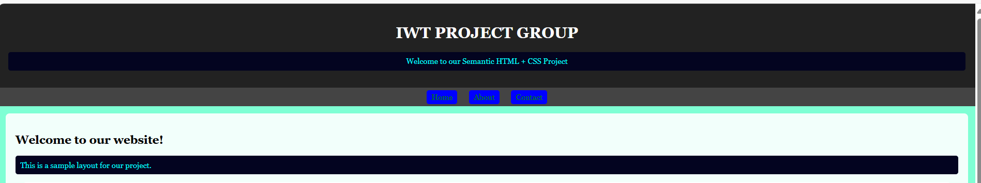

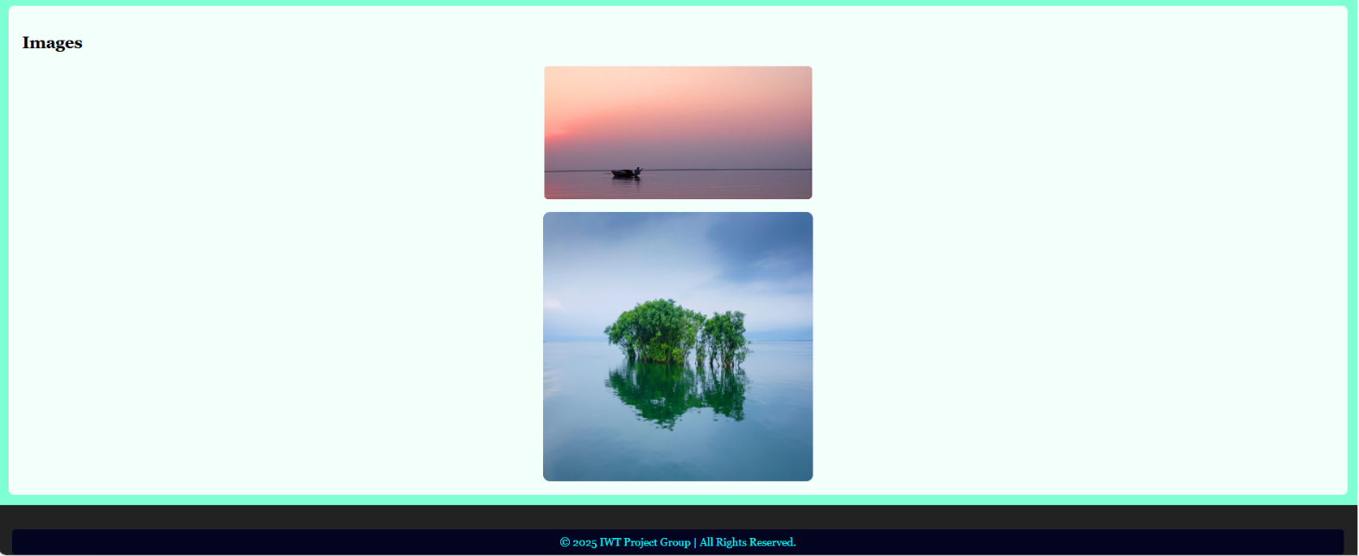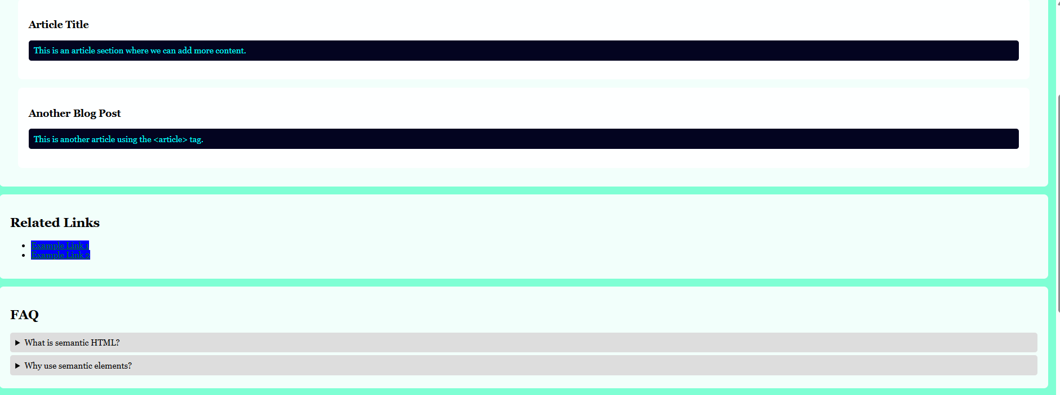

Lab Class-03

# **Html:**

<!DOCTYPE html>

<html lang="en">

<head>

  <meta charset="UTF-8" />

  <meta name="viewport" content="width=device-width, initial-scale=1.0"/>

  <title>Internet and Web Technology</title>

  <link rel="stylesheet" href="/Lab Class-3/Css/style.css">

</head>

<body>

*<!-- Navigation -->*

  <nav>

    <a href="#intro">Introduction</a>

    <a href="#table">Student Info</a>

    <a href="#subjects">Subjects</a>

    <a href="#technologies">Technologies</a>

    <a href="#definitions">Key Terms</a>

  </nav>

*<!-- Introduction Section -->*

  <div id="intro" class="section">

    <h2>Introduction to Internet and Web Technology</h2>

    <p>The internet is a global network that connects millions of computers worldwide, enabling communication and data exchange.</p>

    <p>Web technology refers to the tools and techniques used to create websites and web applications, including HTML, CSS, JavaScript, and server-side technologies.</p>

  </div>

*<!-- Student Information Table -->*

  <div id="table" class="section">

    <h2>Student Information Table</h2>

    <table>

      <tr>

        <th>University Name</th>

        <th>Student Name</th>

        <th>Student Number</th>

      </tr>

      <tr>

        <td>Jahangirnagar University</td>

        <td>Shaon Magi</td>

        <td>0178199222</td>

      </tr>

      <tr>

        <td>Barisal University</td>

        <td>Ahad Ali</td>

        <td>01581719950</td>

      </tr>

    </table>

  </div>

*<!-- Subjects Section -->*

  <div id="subjects" class="section">

    <h2>Subjects in Web Technology</h2>

    <ol>

      <li>HTML & CSS</li>

      <li>JavaScript</li>

      <li>PHP & MySQL</li>

      <li>React.js</li>

      <li>Node.js</li>

    </ol>

  </div>

*<!-- Technologies Section -->*

  <div id="technologies" class="section">

    <h2>Popular Web Technologies</h2>

    <ul>

      <li>Bootstrap</li>

      <li>Tailwind CSS</li>

      <li>WordPress</li>

      <li>MongoDB</li>

      <li>Laravel</li>

    </ul>

  </div>

*<!-- Key Terms Section -->*

  <div id="definitions" class="section">

    <h2>Key Web Technology Terms</h2>

    <dl>

      <dt>HTML (HyperText Markup Language)</dt>

      <dd>The standard language used to create and design webpages.</dd>

      <dt>CSS (Cascading Style Sheets)</dt>

      <dd>A style sheet language used for describing the look and formatting of a document written in HTML.</dd>

      <dt>JavaScript</dt>

      <dd>A programming language used to create dynamic and interactive effects on webpages.</dd>

      <dt>PHP (Hypertext Preprocessor)</dt>

      <dd>A server-side scripting language used for web development.</dd>

      <dt>MySQL</dt>

      <dd>An open-source relational database management system.</dd>

    </dl>

  </div>

</body>

</html>

# **Css:**

body {

font-family: Arial, sans-serif;

margin: 0;

padding: 0;

background-color: #f8f8f8;

text-align: center;

}

/* Navigation Bar */

nav {

background-color: #333;

padding: 15px;

position: fixed;

width: 100%;

top: 0;

left: 0;

z-index: 1000;

}

nav a {

color: white;

text-decoration: none;

padding: 10px 20px;

margin: 0 10px;

display: inline-block;

font-size: 18px;

border-radius: 5px;

}

nav a:hover {

background-color: #575757;

}

/* Sections */

.section {

background-color: white;

margin: 80px auto;

padding: 20px;

border-radius: 8px;

width: 60%;

box-shadow: 2px 2px 10px rgba(0, 0, 0, 0.1);

text-align: left;

}

/* Table */

table {

width: 100%;

border-collapse: collapse;

margin-top: 10px;

}

th, td {

border: 1px solid black;

padding: 10px;

text-align: center;

}

th {

background-color: #f2f2f2;

}

/* Ordered & Unordered Lists */

ul, ol {

width: 80%;

margin: auto;

margin-top: 10px;

}

/* Definition List */

dl {

width: 80%;

margin: auto;

margin-top: 10px;

}

dt {

font-weight: bold;

margin-top: 10px;

}

dd {

margin-left: 20px;

margin-bottom: 10px;}

# **Output:**

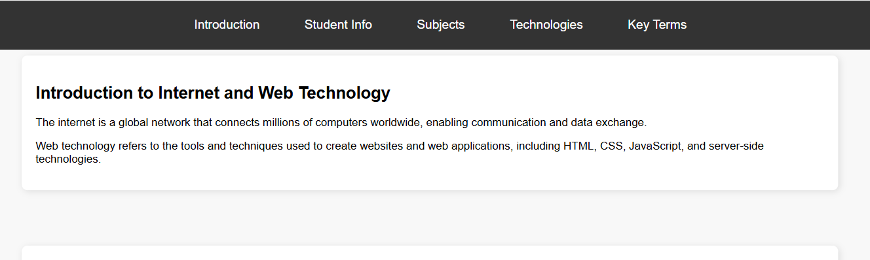

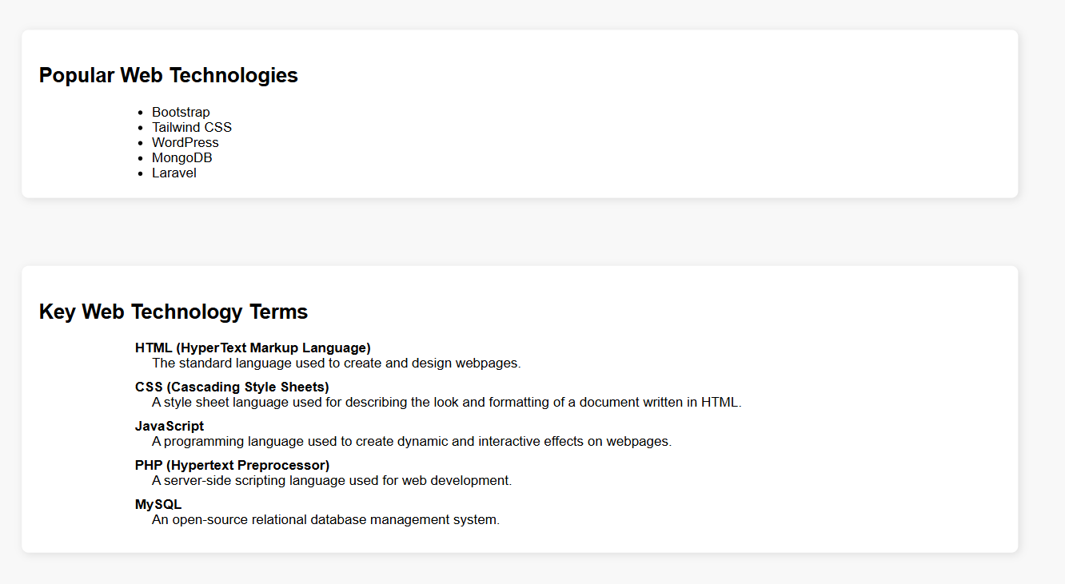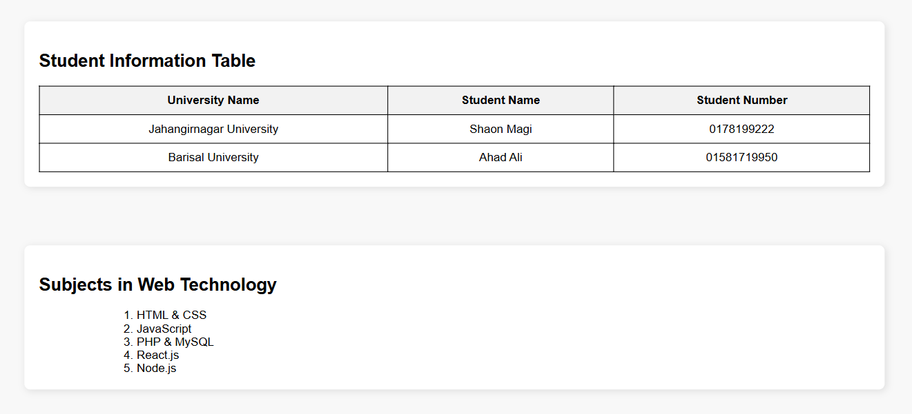

**Lab Class-04**

# **Html:**

<!DOCTYPE html>

<html lang="en">

<head>

<meta charset="UTF-8" />

<meta name="viewport" content="width=device-width, initial-scale=1.0" />

<title>Computer Info & Test Divs</title>

<link rel="stylesheet" href="/Lab Class-4/css/style.css" />

<style>

h1 {

color: aliceblue;

text-align: center;

}

</style>

</head>

<body>

<!-- Table Section -->

<h1>Computer Information</h1>

<table>

<caption>Computer Info</caption>

<tr>

<th>Computer</th>

<th>Company</th>

<th>Country</th>

</tr>

<tr>

<td>

<ul>

<li><b>Coffee</b></li>

<li>Mug</li>

</ul>

</td>

<td>Centro</td>

<td>Ernst</td>

</tr>

<tr>

<td>Alfreds</td>

<td>Centro</td>

<td>Ernst</td>

</tr>

</table>

<!-- Test Divs -->

<div class="test">

Lorem ipsum dolor sit amet consectetur adipisicing elit. Iste non nisi,

hic autem minima minus commodi modi repudiandae ratione nemo quos aliquam

<p>

Explicabo rerum aut quas, ipsam fugit mollitia sapiente atque quidem?

Quasi, praesentium voluptates, voluptatibus, ut ducimus inventore quia

doloremque repellendus quaerat officiis eaque minus eos saepe? Alias

nobis, iusto nam minima iste rem repellendus inventore temporibus animi

facilis! Repudiandae optio quod ut enim accusamus provident.

</p>

</div>

<div class="test">

Lorem ipsum dolor sit amet consectetur adipisicing elit. Iste non nisi,

hic autem minima minus commodi modi repudiandae ratione nemo quos aliquam

explicabo rerum aut quas, ipsam fugit mollitia sapiente atque quidem?

Quasi, praesentium voluptates, voluptatibus, ut ducimus inventore quia

doloremque repellendus quaerat officiis eaque minus eos saepe? Alias

nobis, iusto nam minima iste rem repellendus inventore temporibus animi

facilis! Repudiandae optio quod ut enim accusamus provident.

</div>

<div class="test">

Lorem ipsum dolor sit amet consectetur adipisicing elit. Iste non nisi,

hic autem minima minus commodi modi repudiandae ratione nemo quos aliquam

explicabo rerum aut quas, ipsam fugit mollitia sapiente atque quidem?

Quasi, <span id="myspan">praesentium</span> voluptates, voluptatibus,

ut ducimus inventore quia doloremque repellendus quaerat officiis eaque

minus eos saepe? Alias nobis, iusto nam minima iste rem repellendus

inventore temporibus animi facilis! Repudiandae optio quod ut enim

accusamus provident.

</div>

<!-- Iframe Section -->

<iframe class="center" src="secondpage.html" width="500px" height="500px"></iframe>

<!-- Form Section -->

<form action="secondpage.html">

<label for="fname">First Name</label>

<input type="text" name="fname" id="fname"> <br>

<label for="lname">Last Name</label>

<input type="text" name="lname" id="lname"> <br>

<input type="submit">

</form>

</body>

</html>

# **CSS:**

/* Table Styles */

table {

background-color: rgb(183, 255, 231);

border: 1px solid green;

width: 50%;

height: 100px;

margin-left: auto;

margin-right: auto;

padding-left: 20px;

}

tr, th, td {

border: 1px solid green;

border-radius: 20%;

}

tr:nth-child(even) {

background-color: bisque;

}

/* Test Divs */

.test {

background-color: bisque;

border-radius: 20%;

color: black;

width: 300px;

height: 300px;

float: left;

padding: 40px;

border: 2px solid green;

margin: 20px;

}

#myspan {

color: blueviolet;

}

.center {

display: flex;

margin-left: auto;

margin-right: auto;

}

/* Paragraph First Line */

p::first-line {

background-color: burlywood;

font-variant: small-caps;

}

/* Form Input */

input[type=text], select {

width: 50%;

padding: 12px 20px;

margin: 8px 0;

display: inline-block;

border: 1px solid cyan;

border-radius: 1px;

box-sizing: border-box;

}

# **Output**

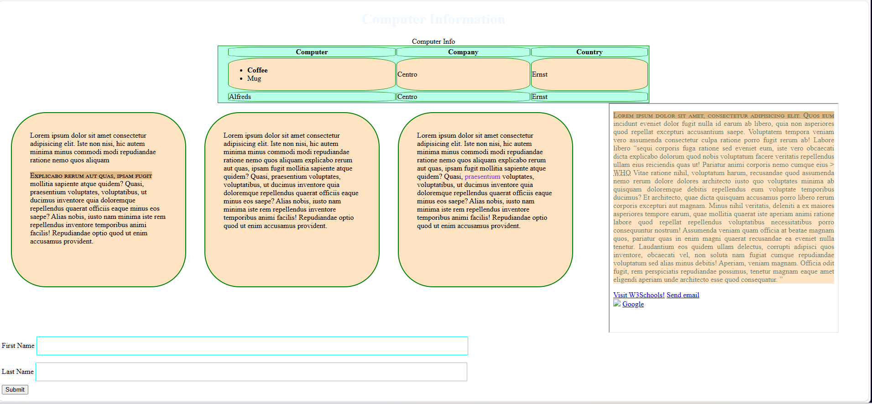

**Lab Class-05**

# **Html:**

<!DOCTYPE html>

<html lang="en">

<head>

  <meta charset="UTF-8" />

  <meta name="viewport" content="width=device-width, initial-scale=1.0" />

  <title>Lab Class 5</title>

  <link

    href="https://cdn.jsdelivr.net/npm/bootstrap@5.0.2/dist/css/bootstrap.min.css"

    rel="stylesheet"

    integrity="sha384-EVSTQN3/azprG1Anm3QDgpJLIm9Nao0Yz1ztcQTwFspd3yD65VohhpuuCOmLASjC"

    crossorigin="anonymous"

  />

  <style>

    body {

        background-color: #e6f2ff;

        font-family: 'Segoe UI', Tahoma, Geneva, Verdana, sans-serif;

        color: #333;

    }

    .container {

        background-color: #ffffff;

        padding: 30px;

        border-radius: 15px;

        box-shadow: 0 8px 25px rgba(0, 0, 0, 0.1);

    }

    header h1 {

        color: #0056b3;

        font-weight: 700;

        text-shadow: 1px 1px 2px rgba(0,0,0,0.1);

    }

    header p.lead {

        color: #3b3b3b;

        font-size: 1.1rem;

    }

    .row > .col-md {

        padding: 25px;

        border-radius: 12px;

        background: linear-gradient(145deg, #cce6ff, #99ccff);

        transition: transform 0.3s, box-shadow 0.3s;

        color: #003366;

    }

    .row > .col-md:hover {

        transform: translateY(-5px);

        box-shadow: 0 12px 25px rgba(0,0,0,0.15);

    }

    blockquote {

        font-size: 1.2rem;

        font-style: italic;

        color: #6a4c93;

        border-left: 5px solid #ff9933;

        padding-left: 20px;

        margin: 20px auto;

        max-width: 700px;

    }

    .figure-caption {

        font-size: 0.9rem;

        color: #555;

        margin-top: 5px;

    }

    .gallery img,

    .figure-img {

        border-radius: 12px;

        transition: transform 0.3s, box-shadow 0.3s;

        cursor: pointer;

    }

    .gallery img:hover,

    .figure-img:hover {

        transform: scale(1.05);

        box-shadow: 0 10px 25px rgba(0, 0, 0, 0.2);

    }

  </style>

</head>

<body>

  <div class="container mt-5 p-4">

    <header class="text-center mb-5">

      <h1 class="display-3">LAB CLASS-5</h1>

      <p class="lead">Bootstrap Layout Example with Columns, Images, and Blockquotes</p>

    </header>

    <section class="row mb-5 g-4">

      <div class="col-md p-4 rounded shadow-sm">

        <p>Lorem ipsum dolor sit amet consectetur adipisicing elit. Incidunt quasi voluptate dolor ab. Consequuntur blanditiis voluptates quibusdam perferendis minus dicta error veniam, fuga voluptatum illo cupiditate in et sequi eos!</p>

      </div>

      <div class="col-md p-4 rounded shadow-sm">

        <p>Lorem ipsum dolor sit, amet consectetur adipisicing elit. Voluptatem cumque fuga omnis? Neque dolorem ipsa laborum repellendus assumenda, suscipit inventore error eos possimus id qui voluptas. Est ut repellat explicabo.</p>

      </div>

      <div class="col-md p-4 rounded shadow-sm">

        <p>Lorem ipsum dolor sit, amet consectetur adipisicing elit. Praesentium, inventore soluta! Libero quasi praesentium omnis quaerat ab eligendi, vero consequatur.</p>

      </div>

    </section>

    <hr class="border-secondary mb-5">

    <section class="mb-5">

      <figure class="text-center">

        <blockquote class="blockquote">

          <p class="fs-5">"A well-known quote, contained in a blockquote element."</p>

        </blockquote>

        <figcaption class="blockquote-footer">

          Someone famous in <cite title="Source Title">Source Title</cite>

        </figcaption>

      </figure>

    </section>

    <section class="text-center mb-5">

      <figure class="figure d-inline-block mx-2">

        <img src="images/rainyday.jpg" class="figure-img img-fluid rounded shadow-sm" alt="Rainy Day" style="max-width: 300px;">

        <figcaption class="figure-caption text-center">A Rainy Day</figcaption>

      </figure>

      <figure class="figure d-inline-block mx-2">

        <img src="images/hill.jpg" class="figure-img img-fluid rounded shadow-sm" alt="Hill View" style="max-width: 300px;">

        <figcaption class="figure-caption text-center">Hill View</figcaption>

      </figure>

      <figure class="figure d-inline-block mx-2">

        <img src="images/sea.jpg" class="figure-img img-fluid rounded shadow-sm" alt="Sea View" style="max-width: 300px;">

        <figcaption class="figure-caption text-center">Sea View</figcaption>

      </figure>

    </section>

  </div>

  <script

    src="https://cdn.jsdelivr.net/npm/bootstrap@5.0.2/dist/js/bootstrap.bundle.min.js"

    integrity="sha384-MrcW6ZMFYlzcLA8Nl+NtUVF0sA7MsXsP1UyJoMp4YLEuNSfAP+JcXn/tWtIaxVXM"

    crossorigin="anonymous"

  ></script>

</body>

</html>

**Output :**

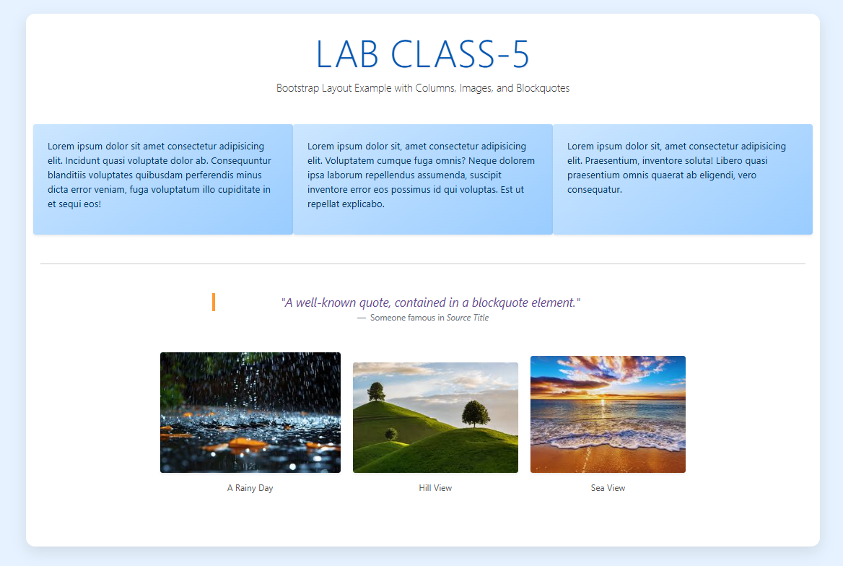

**Lab Class-06**

# **Html:**

<!DOCTYPE html>

<html lang="en">

<head>

<meta charset="UTF-8" />

<meta name="viewport" content="width=device-width, initial-scale=1.0" />

<title>internet and web tecnology lab-5</title>

<link

href="https://cdn.jsdelivr.net/npm/bootstrap@5.0.2/dist/css/bootstrap.min.css"

rel="stylesheet"

integrity="sha384-EVSTQN3/azprG1Anm3QDgpJLIm9Nao0Yz1ztcQTwFspd3yD65VohhpuuCOmLASjC"

crossorigin="anonymous"

/>

<link rel="stylesheet" href="/Lab class-6/style.css" >

</head>

<body >

<div class="pic"><img src="/images/iwt-letter-initial-logo-design-600nw-2082356140.webp" width="100" height="100">

</div>

<div class="container-sm mt-4 light-blue">

<div class="img">Barca fan

<img src="/images/paYnEE8hcrP96neHRNofhQ_64x64.png" alt="barca">

</div>

<div class="mb-3"

<div class="row">

<div class="col-6 "> <label for="exampleFormControlInput1" class="form-label"

>FULL name</label><input

type="name"

class="form-control"

id="exampleFormControlInput1"

placeholder="md ahad ali"

/></div>

<div class="col-6"><label for="exampleFormControlInput1" class="form-label"

>SURNAME</label

><input

type="SURNAME"

class="form-control"

id="exampleFormControlInput1"

placeholder="ahad"

/></div>

</div>

<div class="row">

<div class="col-6 mt-2"> <label for="exampleFormControlInput1" class="form-label"

>Email address</label><input

type="email"

class="form-control"

id="exampleFormControlInput1"

placeholder="name@example.com"

/></div>

<div class="col-6 mt-2"><label for="exampleFormControlInput1" class="form-label"

>password</label

><input

type="password"

class="form-control"

id="exampleFormControlInput1"

placeholder="*******"

/></div>

</div>

<div class="row">

<div class="col-6 mt-2"> <label for="exampleFormControlInput1" class="form-label"

>ADDRESS</label><input

type="Adress"

class="form-control"

id="exampleFormControlInput1"

placeholder="savar,dhaka"

/></div>

<div class="col-6 mt-2"><label for="exampleFormControlInput1" class="form-label"

>MOBILE</label

><input

type="number"

class="form-control"

id="exampleFormControlInput1"

placeholder="01*******"

/></div>

</div>

<form><label for="exampleDataList" class="form-label mt-2">A unit Subject list </label>

<input class="form-control" list="datalistOptions" id="exampleDataList" placeholder="Type to search...">

<datalist id="datalistOptions">

<option value="CSE">

<option value="IIT">

<option value="CHEMISTRY">

<option value="PHYSICS">

<option value="Statistics">

<option value="Environmental sciences">

<option value=" Geological Science">

</datalist>

</form>

<div class="col-6 mt-2"><label for="exampleFormControlInput1" class="form-label"

>CODING LANGUAGE</label>

<div class="form-check">

<input class="form-check-input" type="checkbox" value="" id="flexCheckDefault">

<label class="form-check-label" for="flexCheckDefault">

JAVA

</label>

</div>

<div class="form-check">

<input class="form-check-input" type="checkbox" value="" id="flexCheckChecked" checked>

<label class="form-check-label" for="flexCheckChecked">

PYTHON

</label>

</div>

<div class="form-check">

<input class="form-check-input" type="checkbox" value="" id="flexCheckChecked" checked>

<label class="form-check-label" for="flexCheckChecked">

HTML

</label>

</div>

<div class="form-check">

<input class="form-check-input" type="checkbox" value="" id="flexCheckChecked" checked>

<label class="form-check-label" for="flexCheckChecked">

CSS

</label>

</div>

</div>

<div class="mb-3">

<label for="exampleFormControlTextarea1" class="form-label"

>Example textarea</label

>

<textarea

class="form-control"

id="exampleFormControlTextarea1"

rows="3"

></textarea>

</div>

<input

class="form-control form-control-lg"

type="text"

placeholder=".form-control-lg"

aria-label=".form-control-lg example"

/>

</div>

<script

src="https://cdn.jsdelivr.net/npm/bootstrap@5.0.2/dist/js/bootstrap.bundle.min.js"

integrity="sha384-MrcW6ZMFYlzcLA8Nl+NtUVF0sA7MsXsP1UyJoMp4YLEuNSfAP+JcXn/tWtIaxVXM"

crossorigin="anonymous"

></script>

</body>

</html>

# **CSS:**

body{

background-color: antiquewhite;

color: rgb(210, 125, 22);

}

.pic {

display: block;

margin-left: auto;

margin-right: auto;

}

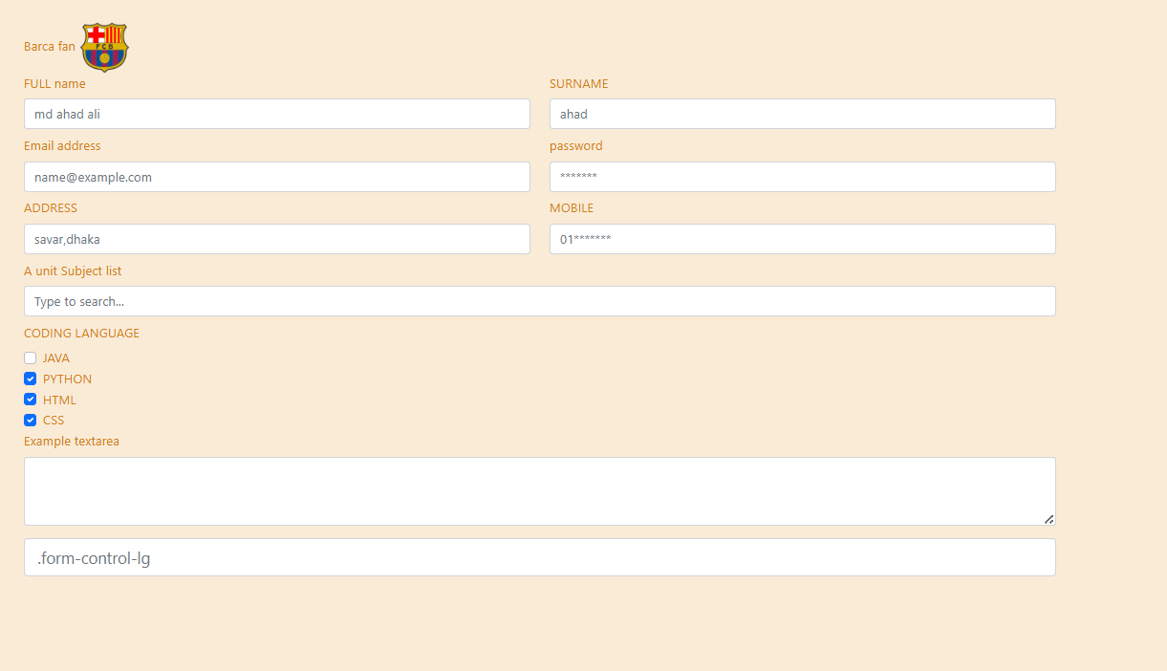**output**

**Lab Class-07**

# **Html:**

<!DOCTYPE html>

<html lang="en">

<head>

<meta charset="UTF-8">

<meta name="viewport" content="width=device-width, initial-scale=1.0">

<title>Bangladesh Divisions</title>

<link href="https://cdn.jsdelivr.net/npm/bootstrap@5.3.0/dist/css/bootstrap.min.css" rel="stylesheet">

</head>

<body class="p-4">

<!-- Breadcrumb -->

<nav aria-label="breadcrumb">

<ol class="breadcrumb">

<li class="breadcrumb-item"><a href="#">Home</a></li>

<li class="breadcrumb-item active" aria-current="page">Bangladesh Divisions</li>

</ol>

</nav>

<!-- Alert -->

<div class="alert alert-info" role="alert">

Explore all 8 divisions of Bangladesh with detailed information.

</div>

<!-- Buttons and Button Group -->

<div class="btn-group mb-4" role="group" aria-label="Division navigation">

<button type="button" class="btn btn-primary">All Divisions <span class="badge text-bg-light">8</span></button>

<button type="button" class="btn btn-secondary">Dhaka</button>

<button type="button" class="btn btn-secondary">Chittagong</button>

<button type="button" class="btn btn-secondary">Khulna</button>

<button type="button" class="btn btn-secondary">Rajshahi</button>

</div>

<!-- Accordion -->

<div class="accordion" id="divisionAccordion">

<!-- Dhaka Division -->

<div class="accordion-item">

<h2 class="accordion-header" id="headingOne">

<button class="accordion-button" type="button" data-bs-toggle="collapse" data-bs-target="#collapseOne" aria-expanded="true" aria-controls="collapseOne">

Dhaka Division <span class="badge bg-success ms-2">13 Districts</span>

</button>

</h2>

<div id="collapseOne" class="accordion-collapse collapse show" aria-labelledby="headingOne" data-bs-parent="#divisionAccordion">

<div class="accordion-body">

<ul>

<li>Dhaka</li>

<li>Faridpur</li>

<li>Gazipur</li>

<li>Gopalganj</li>

<li>Kishoreganj</li>

<li>Madaripur</li>

<li>Manikganj</li>

<li>Munshiganj</li>

<li>Narayanganj</li>

<li>Narsingdi</li>

<li>Rajbari</li>

<li>Shariatpur</li>

<li>Tangail</li>

</ul>

</div>

</div>

</div>

<!-- Chittagong Division -->

<div class="accordion-item">

<h2 class="accordion-header" id="headingTwo">

<button class="accordion-button collapsed" type="button" data-bs-toggle="collapse" data-bs-target="#collapseTwo" aria-expanded="false" aria-controls="collapseTwo">

Chittagong Division <span class="badge bg-info ms-2">11 Districts</span>

</button>

</h2>

<div id="collapseTwo" class="accordion-collapse collapse" aria-labelledby="headingTwo" data-bs-parent="#divisionAccordion">

<div class="accordion-body">

<ul>

<li>Chittagong</li>

<li>Cox's Bazar</li>

<li>Feni</li>

<li>Khagrachari</li>

<li>Lakshmipur</li>

<li>Bandarban</li>

<li>Rangamati</li>

<li>Chandpur</li>

<li>Comilla</li>

<li>Bhola</li>

<li>Barisal</li>

</ul>

</div>

</div>

</div>

<!-- Khulna Division -->

<div class="accordion-item">

<h2 class="accordion-header" id="headingThree">

<button class="accordion-button collapsed" type="button" data-bs-toggle="collapse" data-bs-target="#collapseThree" aria-expanded="false" aria-controls="collapseThree">

Khulna Division <span class="badge bg-danger ms-2">10 Districts</span>

</button>

</h2>

<div id="collapseThree" class="accordion-collapse collapse" aria-labelledby="headingThree" data-bs-parent="#divisionAccordion">

<div class="accordion-body">

<ul>

<li>Khulna</li>

<li>Jessore</li>

<li>Satkhira</li>

<li>Meherpur</li>

<li>Chuadanga</li>

<li>Jhenidah</li>

<li>Magura</li>

<li>Khulna</li>

<li>Bagerhat</li>

<li>Shariatpur</li>

</ul>

</div>

</div>

</div>

<!-- Rajshahi Division -->

<div class="accordion-item">

<h2 class="accordion-header" id="headingFour">

<button class="accordion-button collapsed" type="button" data-bs-toggle="collapse" data-bs-target="#collapseFour" aria-expanded="false" aria-controls="collapseFour">

Rajshahi Division <span class="badge bg-warning ms-2">8 Districts</span>

</button>

</h2>

<div id="collapseFour" class="accordion-collapse collapse" aria-labelledby="headingFour" data-bs-parent="#divisionAccordion">

<div class="accordion-body">

<ul>

<li>Rajshahi</li>

<li>Naogaon</li>

<li>Pabna</li>

<li>Chandpur</li>

<li>Sirajganj</li>

<li>Bagmara</li>

<li>Rangpur</li>

<li>Bogura</li>

</ul>

</div>

</div>

</div>

<!-- Sylhet Division -->

<div class="accordion-item">

<h2 class="accordion-header" id="headingFive">

<button class="accordion-button collapsed" type="button" data-bs-toggle="collapse" data-bs-target="#collapseFive" aria-expanded="false" aria-controls="collapseFive">

Sylhet Division <span class="badge bg-primary ms-2">4 Districts</span>

</button>

</h2>

<div id="collapseFive" class="accordion-collapse collapse" aria-labelledby="headingFive" data-bs-parent="#divisionAccordion">

<div class="accordion-body">

<ul>

<li>Sylhet</li>

<li>Moulvibazar</li>

<li>Habiganj</li>

<li>Sunamganj</li>

</ul>

</div>

</div>

</div>

<!-- Barisal Division -->

<div class="accordion-item">

<h2 class="accordion-header" id="headingSix">

<button class="accordion-button collapsed" type="button" data-bs-toggle="collapse" data-bs-target="#collapseSix" aria-expanded="false" aria-controls="collapseSix">

Barisal Division <span class="badge bg-dark ms-2">6 Districts</span>

</button>

</h2>

<div id="collapseSix" class="accordion-collapse collapse" aria-labelledby="headingSix" data-bs-parent="#divisionAccordion">

<div class="accordion-body">

<ul>

<li>Barisal</li>

<li>Patuakhali</li>

<li>Bhola</li>

<li>Jhalokathi</li>

<li>Barisal</li>

</ul>

</div>

</div>

</div>

<div class="row">

<div class="col-md-6">

<div class="card" style="width: 500px;">

<img src="/images/natural.avif" class="card-img-top" alt="..." style="object-fit: cover; height: 200px;">

<div class="card-body">

<h5 class="card-title">Natural</h5>

<p class="card-text">Natural beauty of Bangladesh</p>

<a href="https://en.wikipedia.org/wiki/Bangladesh" class="btn btn-primary">Bangladesh</a>

</div>

</div>

</div>

<div class="col-md-6">

<div class="card" style="width: 500px;">

<img src="/images/premium_photo-1668024966086-bd66ba04262f.jpg" class="card-img-top" alt="..." style="object-fit: cover; height: 200px;">

<div class="card-body">

<h5 class="card-title">Natural</h5>

<p class="card-text">Natural beauty of Bangladesh</p>

<a href="https://en.wikipedia.org/wiki/Bangladesh" class="btn btn-primary">Bangladesh</a>

</div>

</div>

</div>

</div>

<div id="carouselExampleFade" class="carousel slide carousel-fade" data-bs-ride="carousel">

<div class="carousel-inner">

<div class="carousel-item active">

<img src="/images/photo-1611175522050-9e702da5b464.avif" class="d-block w-100" alt="Natural Beauty 1" height="500px" width="500">

<p> First one</p>

</div>

<div class="carousel-item">

<img src="/images/photo-1664439126360-4db7ba0605c1.avif" class="d-block w-100" alt="Natural Beauty 2" height="500px" width="500">

</div>

<div class="carousel-item">

<img src="/images/photo-1665932201890-3dee0df59704.avif" class="d-block w-100" alt="Natural Beauty 3"height="500px" width="500">

</div>

<div class="carousel-item">

<img src="/images/photo-1666727569937-1599ac3e88d6.avif" class="d-block w-100" alt="Natural Beauty 4"height="500px" width="500">

</div>

</div>

<button class="carousel-control-prev" type="button" data-bs-target="#carouselExampleFade" data-bs-slide="prev">

<span class="carousel-control-prev-icon" aria-hidden="true"></span>

<span class="visually-hidden">Previous</span>

</button>

<button class="carousel-control-next" type="button" data-bs-target="#carouselExampleFade" data-bs-slide="next">

<span class="carousel-control-next-icon" aria-hidden="true"></span>

<span class="visually-hidden">Next</span>

</button>

</div>

<script src="https://cdn.jsdelivr.net/npm/bootstrap@5.3.0/dist/js/bootstrap.bundle.min.js"></script>

</body>

</html>

# **Output:**

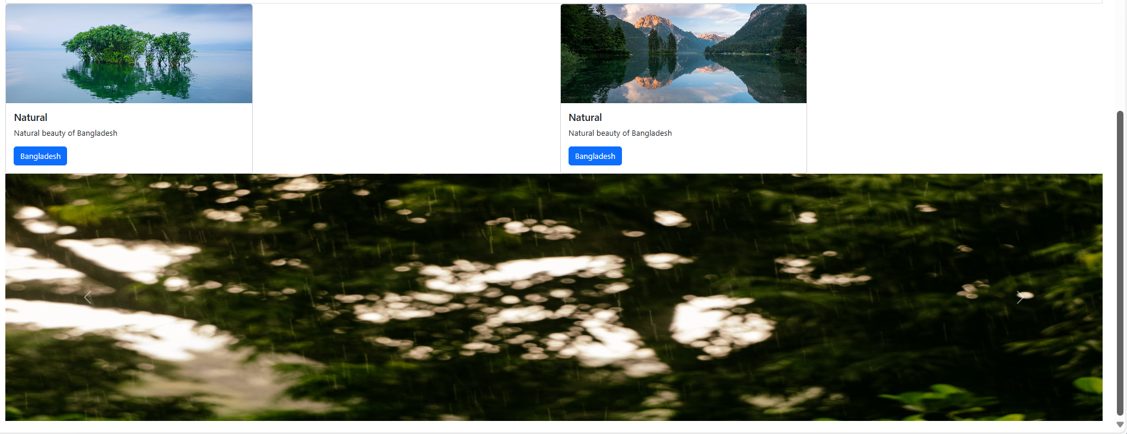

**Lab class-08**

# **Html:**

<!DOCTYPE html>

<html lang="en">

<head>

  <meta charset="UTF-8" />

  <meta name="viewport" content="width=device-width, initial-scale=1.0" />

  <title>Sleek JS Demo</title>

  <link href="https://cdn.jsdelivr.net/npm/bootstrap@5.3.5/dist/css/bootstrap.min.css" rel="stylesheet" crossorigin="anonymous" />

  <style>

    body {

      background: linear-gradient(135deg, #667eea, #764ba2);

      min-height: 100vh;

      display: flex;

      align-items: center;

      justify-content: center;

      font-family: 'Segoe UI', Tahoma, Geneva, Verdana, sans-serif;

    }

    .demo-container {

      background: #ffffff;

      border-radius: 16px;

      padding: 40px;

      max-width: 800px;

      width: 100%;

      box-shadow: 0 12px 40px rgba(0, 0, 0, 0.15);

    }

    h1 {

      font-weight: bold;

      color: #4a3f85;

    }

    section {

      background: #f8f9fa;

      border-radius: 12px;

      padding: 20px;

      margin-bottom: 20px;

      transition: transform 0.2s ease, box-shadow 0.2s ease;

    }

    section:hover {

      transform: translateY(-3px);

      box-shadow: 0 8px 20px rgba(0,0,0,0.1);

    }

    button {

      border-radius: 25px !important;

      padding: 8px 20px !important;

    }

  </style>

</head>

<body onload="displayCurrentTime();">

  <div class="demo-container">

    <h1 class="text-center mb-4">✨ Sleek JavaScript Demo ✨</h1>

    <section>

      <h4>Internal JavaScript</h4>

      <p id="internalResult">Click the button to calculate sum using internal JS data.</p>

      <button class="btn btn-primary" onclick="internalSum()">Calculate Internal Sum</button>

    </section>

    <section>

      <h4>Current Time Display</h4>

      <p id="currentTime">Loading...</p>

      <button class="btn btn-outline-secondary" onclick="displayCurrentTime()">Refresh Time</button>

    </section>

    <section>

      <h4>External JavaScript</h4>

      <p id="externalResult">Use external JS variables to calculate sum.</p>

      <button id="externalBtn" class="btn btn-success">Calculate External Sum</button>

    </section>

    <section>

      <h4>Form Input Example</h4>

      <form id="sumForm">

        <div class="mb-3">

          <input type="number" id="num1" class="form-control" placeholder="First Number">

        </div>

        <div class="mb-3">

          <input type="number" id="num2" class="form-control" placeholder="Second Number">

        </div>

        <button type="button" id="formBtn" class="btn btn-info">Calculate Form Sum</button>

      </form>

      <p id="formResult" class="mt-2"></p>

    </section>

    <section>

      <h4>User Interaction</h4>

      <button id="greetBtn" class="btn btn-dark">Enter Name</button>

      <p id="greetResult" class="mt-2"></p>

    </section>

  </div>

*<!-- External JS -->*

  <script src="/Lab Class-8/JS/index.js"></script>

  <script src="https://cdn.jsdelivr.net/npm/bootstrap@5.3.5/dist/js/bootstrap.bundle.min.js" crossorigin="anonymous"></script>

</body>

</html>

# **Js**

const internalData = { valueA: 18, valueB: 32 };

function internalSum() {

const result = internalData.valueA + internalData.valueB;

document.getElementById("internalResult").textContent = `Internal JS Sum: ${result}`;

}

function displayCurrentTime() {

const now = new Date();

document.getElementById("currentTime").textContent = `Current Time: ${now.toLocaleTimeString()}`;

}

const externalData = { x: 23, y: 12 };

function externalSum() {

const result = externalData.x + externalData.y;

document.getElementById("externalResult").textContent = `External JS Sum: ${result}`;

}

function calculateFormSum() {

const num1 = parseFloat(document.getElementById("num1").value);

const num2 = parseFloat(document.getElementById("num2").value);

if (isNaN(num1) || isNaN(num2)) {

document.getElementById("formResult").textContent = "⚠️ Please enter valid numbers.";

return;

}

const sum = num1 + num2;

document.getElementById("formResult").textContent = `Form JS Sum: ${sum}`;

}

function greetUser() {

const name = prompt("Please enter your name:");

if (name && name.trim() !== "") {

document.getElementById("greetResult").textContent = `👋 Hello, ${name}. Welcome to the demo page.`;

} else {

document.getElementById("greetResult").textContent = "No name entered.";

}

}

document.getElementById("externalBtn").addEventListener("click", externalSum);

document.getElementById("formBtn").addEventListener("click", calculateFormSum);

document.getElementById("greetBtn").addEventListener("click", greetUser);

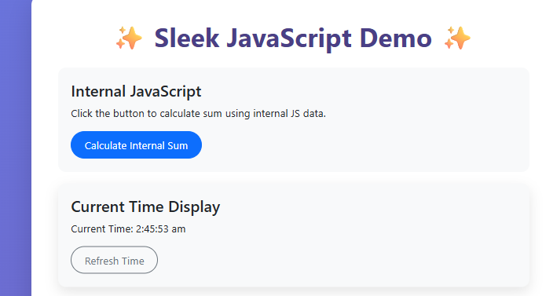 **Output**

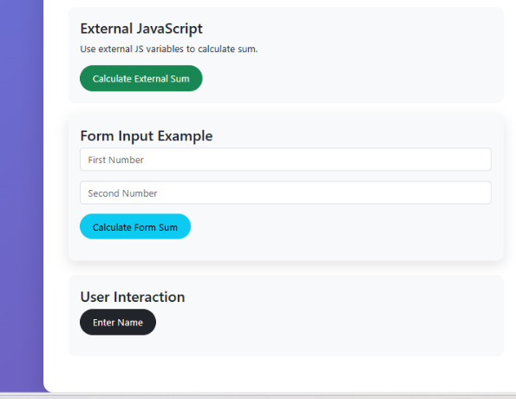

**Lab Class-09**

**Html**

<!DOCTYPE html>

<html lang="en">

<head>

<meta charset="UTF-8">

<meta name="viewport" content="width=device-width, initial-scale=1.0">

<title>JavaScript Interactive Demo</title>

<style>

body {

font-family: Arial, sans-serif;

background: linear-gradient(135deg, #e0f7fa, #e1bee7);

color: #333;

padding: 20px;

}

h1 {

text-align: center;

color: #2c3e50;

margin-bottom: 30px;

}

.output {

max-width: 700px;

margin: 0 auto;

background-color: #ffffff;

padding: 20px;

border-radius: 12px;

box-shadow: 0 5px 20px rgba(0,0,0,0.1);

}

.item {

background: #f9f9f9;

padding: 12px 15px;

margin: 8px 0;

border-left: 5px solid #4a90e2;

border-radius: 8px;

font-size: 16px;

}

.highlight {

color: #4a148c;

font-weight: bold;

}

</style>

</head>

<body>

<h1>JavaScript Interactive Demo</h1>

<div class="output" id="output"></div>

<script src="/Lab Class-9/js/lab_ex.js"></script>

</body>

</html>

# **Js**

const output = document.getElementById("output");

// helper function to print formatted lines

function printLine(text) {

const div = document.createElement("div");

div.className = "item";

div.innerHTML = text;

output.appendChild(div);

}

// Basic Numbers

let x = 23, y = 12;

printLine(`Sum of x + y: <span class="highlight">${x + y}</span>`);

let a = 13, b = 16;

printLine(`Value of a: ${a}`);

printLine(`Value of b: ${b}`);

// Different types

let c = 14, d = 34.675;

let fullName = "Shaon Khan";

printLine(`Type of c: ${typeof c}`);

printLine(`Type of d: ${typeof d}`);

printLine(`Full Name: ${fullName}`);

// Type conversion

let age = 25;

age = age.toString();

printLine(`Age as string: ${age} (Type: ${typeof age})`);

let temp = "100";

temp = parseInt(temp);

printLine(`Temp as number: ${temp} (Type: ${typeof temp})`);

let r = 5.6;

printLine(`r as number: ${Number(r)}`);

let z = "9.7";

z = parseFloat(z);

printLine(`z as float: ${z}`);

let g = 1000.02;

printLine(`g.toFixed(2): ${g.toFixed(2)}`);

printLine(`g.toPrecision(3): ${g.toPrecision(3)}`);

// User input numbers

let num1 = prompt("Enter first number:");

let num2 = prompt("Enter second number:");

num1 = Number(num1);

num2 = Number(num2);

if (isNaN(num1) || isNaN(num2)) {

printLine("❌ Invalid input! Please enter valid numbers.");

} else {

printLine(`Addition: ${num1 + num2}`);

printLine(`Subtraction: ${num1 - num2}`);

printLine(`Multiplication: ${num1 * num2}`);

printLine(`Division: ${num2 !== 0 ? (num1 / num2).toFixed(2) : '⚠️ Cannot divide by zero'}`);

printLine(`Area of Rectangle (num1 × num2): ${num1 * num2}`);

let celsius = (num1 - 32) * 5 / 9;

printLine(`Converted to Celsius: ${celsius.toFixed(2)} °C`);

}

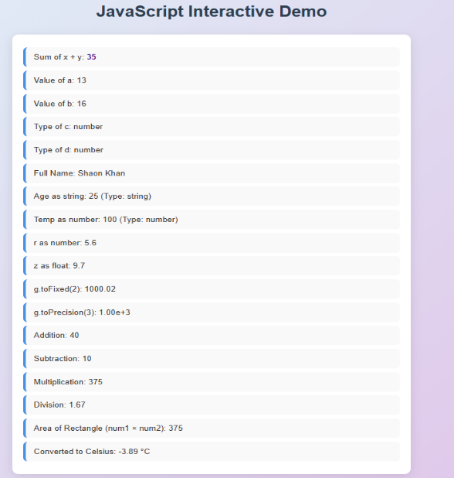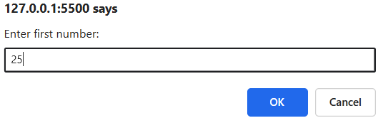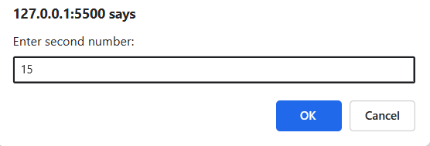**Output**

**Lab Class-10**

# **Html**

<!DOCTYPE html>

<html lang="en">

<head>

<meta charset="UTF-8">

<meta name="viewport" content="width=device-width, initial-scale=1.0">

<title>JS Demo Short</title>

<style>

body {font-family: sans-serif; background:#f4f7fa; padding:20px;}

.container {background:#fff; padding:20px; border-radius:10px; box-shadow:0 5px 15px rgba(0,0,0,0.1);}

h1,h2{text-align:center; color:#2c3e50;}

.output {background:#f1f3f6; padding:15px; border-radius:8px; margin-top:20px; font-family:monospace; white-space:pre-wrap;}

.red{color:red;font-weight:bold;} .blue{color:blue;font-weight:bold;}

</style>

</head>

<body>

<div class="container">

<h1>JavaScript Short Demo</h1>

<div id="output" class="output"></div>

</div>

<script src="/Lab Class-10/js/index.js"></script>

</body>

</html>

# **Js**

const out = msg => document.getElementById("output").innerHTML += msg + "\n";

let a = +prompt("Enter a number:");

let b = +prompt("Enter another number:");

let n = +prompt("How many names?");

let names = Array.from({length:n},(_,i)=>prompt(`Name ${i+1}:`));

*// Condition check*

out(`Conditional: <span class='red'>${a>10?(a===12?"A=12":"A>10 but not 12"):"A<=10"}</span>`);

*// Functions*

let cube = x => x**3;

let mul = (x,y) => x*y;

out(`Square of ${a}: <span class='red'>${a**2}</span>`);

out(`Cube of ${a}: <span class='red'>${cube(a)}</span>`);

out(`Area: <span class='red'>${mul(a,b)}</span>`);

*// IIFE*

(()=>{out(`IIFE Square: <span class='red'>${b**2}</span>\nIIFE Cube: <span class='red'>${cube(b)}</span>`);})();

*// Arrays*

out(`Names: <span class='blue'>${names}</span>`);

let arr = names.slice(0,3);

arr.unshift("AAA"); arr.splice(1,1,"InsertedName"); arr.push("NewName"); arr.pop(); arr.shift();

out(`Modified: ${arr}`);

let arr2D=[[1,'A'],[3,'B'],[4,'C']];

arr2D.forEach(r=>out(r.join(" ")));

out(`Sorted Strings: ${[32,45,78].sort()}`);

out(`Sorted Numbers: ${[1230000000,125499999,12000000].sort((x,y)=>x-y)}`);

*// Type conversion*

let bNum=+prompt("Enter number:"), cStr=prompt("Enter string:"), vNum=+prompt("Float:");

out(`bNum: ${typeof bNum}, cStr: ${typeof cStr}, vNum: ${typeof vNum}`);

out(`Num→Str: ${bNum.toString()} (${typeof bNum.toString()})`);

out(`Str→Num: ${parseFloat(prompt("Enter numeric string:"))}`);

out(`Invalid Num: ${Number("ASDDDF")}`);

out(`Fixed(3): ${vNum.toFixed(3)}, Precision(5): ${vNum.toPrecision(5)}`);

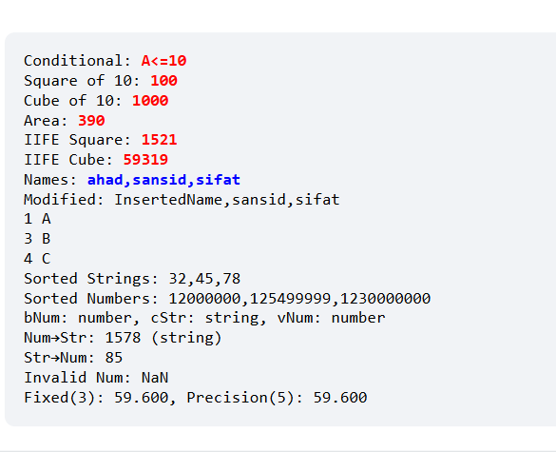**Output**

**Lab Class-11**

# **Html**

<!DOCTYPE html>

<html lang="en">

<head>

<meta charset="UTF-8" />

<meta name="viewport" content="width=device-width, initial-scale=1.0" />

<title>JavaScript DOM Demo - Students</title>

<style>

body { font-family: Arial, sans-serif; background: #f0f4f8; padding: 20px; }

.head { color: #2c3e50; font-size: 16px; }

.header2 { color: #34495e; font-weight: bold; }

.my-div a { padding: 5px 12px; background: #3498db; color: #fff; text-decoration: none; border-radius: 5px; }

.highlight { color: #e74c3c; font-weight: bold; }

</style>

</head>

<body>

<p id="header3">Welcome to the Student Portal</p>

<p class="header2">Student Details</p>

<p class="head">Here you can find details of male students.</p>

<h3>Header Example 1</h3>

<h3>Header Example 2</h3>

<p>Student1: Arif</p>

<p>Student2: Tanvir</p>

<p>Student3: Rony</p>

<p>Student4: Farhan</p>

<div class="my-div">

<a href="#">Contact</a>

</div>

<script src="/Lab Class-11/js/index.js"></script>

</body>

</html>

# **JS**

var student1 = { name: "Arif", roll: 1001, year: "1st", courses: ["Math", "Physics", "CSE"] };

var student2 = { name: "Tanvir", roll: 1002, year: "2nd", courses: ["English", "History", "Programming"] };

document.writeln(`Name: ${student1.name}, Roll: ${student1.roll}, Year: ${student1.year}, Courses: ${student1.courses}<br>`);

document.writeln(`Name: ${student2.name}<br>Roll: ${student2.roll}<br>Year: ${student2.year}<br>Courses: ${student2.courses}<br>`);

*// Constructor function*

function Student(name, age, roll, year, courses) {

*this*.name = name; *this*.age = age; *this*.roll = roll; *this*.year = year; *this*.courses = courses;

*this*.display = function () {

    document.writeln(`<br>Name: ${*this*.name}<br>Age: ${*this*.age}<br>Roll: ${*this*.roll}<br>Year: ${*this*.year}<br>Courses: ${*this*.courses}`);

  };

}

var std = new Student("Rony", 21, 1003, "2nd", ["DS", "Algorithms"]);

std.display();

document.writeln(`<br>The student has enrolled in <span class="highlight">${std.courses[1]}</span>`);

*// Math object*

document.writeln(`<br><br>Math.pow(2,8) = ${Math.pow(2,8)}`);

document.writeln(`<br>Random (1-10): ${Math.floor(Math.random()*10+1)}`);

var date = new Date();

document.writeln(`<br><br>Year: ${date.getFullYear()} | Hour: ${date.getHours()}`);

document.getElementById("header3").innerHTML = "Welcome to Random Students Portal";

document.getElementsByClassName("head")[0].innerHTML = "<span style='color:green;'>Updated student info</span>";

document.querySelector(".my-div a").innerHTML = "Contact Admin";

*// Another constructor*

function Stud(name, age, roll) {

*this*.name = name; *this*.age = age; *this*.roll = roll;

*this*.display = function () {

    document.writeln(`<br><span style='color:purple;'>Name: ${*this*.name}, Age: ${*this*.age}, Roll: ${*this*.roll}</span>`);

  };

}

var totalStudents = [

  new Stud("Farhan", 22, 1004),

  new Stud("Hasib", 20, 1005),

  new Stud("Imran", 23, 1006)

];

for (var i=0; i<totalStudents.length; i++) totalStudents[i].display();

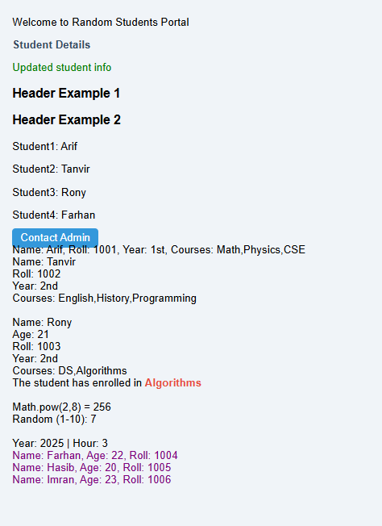Output

**Lab Class-12**

**Html**

<!DOCTYPE html>

<html lang="en">

<head>

<meta charset="UTF-8">

<link rel="stylesheet" href="css/style.css">

<meta name="viewport" content="width=device-width, initial-scale=1.0">

<title>Demo Page</title>

<link href="https://cdn.jsdelivr.net/npm/bootstrap@5.0.2/dist/css/bootstrap.min.css" rel="stylesheet"

integrity="sha384-EVSTQN3/azprG1Anm3QDgpJLIm9Nao0Yz1ztcQTwFspd3yD65VohhpuuCOmLASjC" crossorigin="anonymous">

<style>

body {

background: #f8fafc;

}

.card {

border-radius: 16px;

box-shadow: 0 4px 10px rgba(0, 0, 0, 0.1);

padding: 20px;

background: #fff;

}

#paraID {

font-size: 18px;

line-height: 1.6;

}

.btn-custom {

border-radius: 25px;

padding: 8px 18px;

font-weight: 500;

}

.img-box {

border: 3px solid #dee2e6;

border-radius: 12px;

overflow: hidden;

}

</style>

</head>

<body>

<div class="container my-5">

<div class="card">

<!-- Buttons -->

<div class="mb-4 text-center">

<button class="btn btn-info btn-custom me-2" onmouseover="buttonClick1()">Hello Button</button>

<button class="btn btn-danger btn-custom me-2" onclick="paraClick1()">Hello Button 2</button>

<button class="btn btn-dark btn-custom" onclick="imageClick()">Hello Button 3</button>

</div>

<!-- Paragraph -->

<p id="paraID" class="text-secondary text-center">

Lorem ipsum dolor sit amet consectetur adipisicing elit. Officia totam expedita dignissimos voluptatum a aliquam?

</p>

<!-- Image -->

<div class="img-box mx-auto mb-4" style="width: 320px;">

<img id="imageID" src="/images/photo-1664439126360-4db7ba0605c1.avif" alt="Dynamic Image" class="img-fluid">

</div>

<!-- Slider -->

<div class="text-center">

<div class="img-box mx-auto mb-3" style="width: 320px;">

<img id="slider" src="/images/sundarban.jpg" alt="Slider" class="img-fluid">

</div>

<button class="btn btn-outline-dark btn-custom me-2" onclick="prev()">⬅ Previous</button>

<button class="btn btn-outline-danger btn-custom" onclick="next()">Next ➡</button>

</div>

</div>

</div>

<script src="/Lab Class-12/js/index.js"></script>

<script src="https://cdn.jsdelivr.net/npm/bootstrap@5.0.2/dist/js/bootstrap.bundle.min.js"

integrity="sha384-MrcW6ZMFYlzcLA8Nl+NtUVF0sA7MsXsP1UyJoMp4YLEuNSfAP+JcXn/tWtIaxVXM"

crossorigin="anonymous"></script>

</body>

</html>

**JS**

function buttonClick1() {

alert('Hello Dear');

}

function paraClick() {

document.getElementById('paraID').innerHTML = 'This is second text of the paragraph';

}

function paraClick1() {

document.querySelector('#paraID').innerHTML = 'Hi There! I like you';

}

function imageClick() {

document.querySelector('#imageID').src = "images/photo-1611175522050-9e702da5b464.avif";

}

var images = ['images/nature.jpg', 'images/pic_trulli.jpg', 'images/village-4832378_640.jpg'];

var index = 0;

function showimage() {

document.getElementById('slider').src = images[index];

}

function prev() {

if (index > 0) {

index--;

showimage();

} else {

alert('This is the first image');

}

}

function next() {

if (index < images.length - 1) {

index++;

showimage();

} else {

alert('This is the last image');

}

}

showimage();

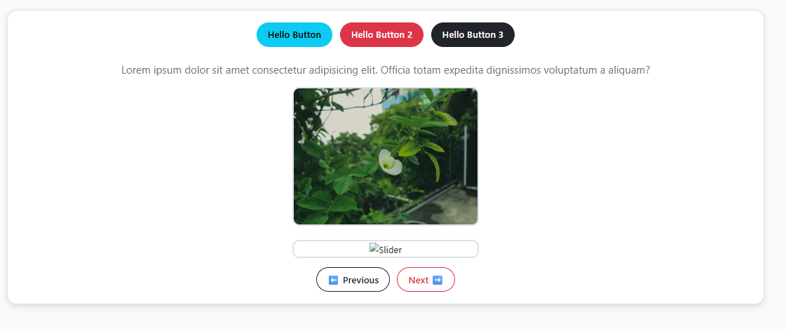Output

**Lab Class-13**

**Html**

<!DOCTYPE html>

<html lang="en">

<head>

<meta charset="UTF-8" />

<meta name="viewport" content="width=device-width, initial-scale=1.0" />

<title>Demo Project</title>

<link rel="stylesheet" href="/Lab Class-13/css/style.css" />

<link

href="https://cdn.jsdelivr.net/npm/bootstrap@5.0.2/dist/css/bootstrap.min.css"

rel="stylesheet"

crossorigin="anonymous"

/>

</head>

<body>

<main class="container my-5">

<section id="paragraph-section" class="mb-4">

<p id="paraId" class="fs-5">

Lorem ipsum dolor sit amet consectetur adipisicing elit. Nam veritatis

provident autem quisquam. Culpa, sequi eos corrupti ab provident

voluptatibus?

</p>

</section>

<section id="button-section" class="mb-4 text-center">

<button id="addButton" class="btn btn-primary me-2">Toggle Style</button>

<button id="removeButton" class="btn btn-danger me-2">

Remove Style

</button>

<a href="/Lab Class-13/template/next.html" class="btn btn-secondary">

Go to Next Page

</a>

</section>

<section

id="output-section"

class="text-center p-3 border rounded bg-light"

></section>

</main>

<script src="/Lab Class-13/js/index.js"></script>

<script

src="https://cdn.jsdelivr.net/npm/bootstrap@5.0.2/dist/js/bootstrap.bundle.min.js"

crossorigin="anonymous"

></script>

</body>

</html>

**CSS**

.para-style {

color: rgb(115, 0, 255);

font-size: 2rem;

font-weight: bold;

font-style: italic;

transition: all 0.3s ease;

}

button {

min-width: 120px;

}

#output-section p {

margin: 5px 0;

font-size: 1.2rem;

font-family: Arial, sans-serif;

}

**Template/next.html**

<!DOCTYPE html>

<html lang="en">

<head>

<meta charset="UTF-8" />

<meta name="viewport" content="width=device-width, initial-scale=1.0" />

<title>Next Page</title>

<link rel="stylesheet" href="../style.css" />

<link

href="https://cdn.jsdelivr.net/npm/bootstrap@5.0.2/dist/css/bootstrap.min.css"

rel="stylesheet"

crossorigin="anonymous"

/>

</head>

<body>

<main class="container my-5 text-center">

<h2 class="mb-4">Next Page</h2>

<button id="backButton" class="btn btn-secondary">Back</button>

</main>

<script src="../script.js"></script>

<script

src="https://cdn.jsdelivr.net/npm/bootstrap@5.0.2/dist/js/bootstrap.bundle.min.js"

crossorigin="anonymous"

></script>

</body>

</html>

**JS**

const para = document.querySelector('#paraId');

const addButton = document.querySelector('#addButton');

const removeButton = document.querySelector('#removeButton');

const outputSection = document.querySelector('#output-section');

*// Toggle and remove style*

function toggleStyle() {

  para.classList.toggle('para-style');

}

function removeStyle() {

  para.classList.remove('para-style');

}

if (addButton) addButton.addEventListener('click', toggleStyle);

if (removeButton) removeButton.addEventListener('click', removeStyle);

*// Back button function (for next.html)*

const backButton = document.querySelector('#backButton');

if (backButton) backButton.addEventListener('click', () => window.history.back());

*// Output helper*

function writeOutput(text) {

  const p = document.createElement('p');

  p.innerHTML = text;

  outputSection.appendChild(p);

}

*// Demo Outputs*

const names = ['Arif', 'Nadia', 'Tanvir', 'Mou', 'Rafi'];

names.forEach(name => writeOutput("Name: " + name));

const person = { id: 101, name: "Random User" };

for (let key in person) {

  writeOutput(`${key}: ${person[key]}`);

}

const numbers = [2, 5, 8, 11];

numbers.forEach(num => writeOutput("Number: " + num));

const display = () => "Hello There!";

writeOutput(display());

const add = (a, b) => a + b;

writeOutput("Add (3+7): " + add(3, 7));

const evenNumbers = numbers.filter(num => num % 2 === 0);

writeOutput("Even Numbers: " + evenNumbers.join(', '));

const squares = numbers.map(num => num * num);

writeOutput("Squares: " + squares.join(', '));

Output

